# EXPERIMENT NUMBER –Practical 1.1

STUDENT’S NAME – SHINDE SMITA SHAHAJI

STUDENT’S UID – 20BCS4643

CLASS AND GROUP –CSE-IOT(GROUP B)

SEMESTER – 2ND

# TOPIC OF EXPERIMENT –

# Program to find average marks of five subjects of a student in a class

# AIM OF THE EXPERIMENT-

# Learn the basics of C++ programming.

# FLOWCHART/ ALGORITHM-

START

# Step 1→ Creating a header file for input output stream and define the context.

# Step 2 → Declaration of function that returns integer value.

# Step 3→ Declaration of variables in integer and float datatype.

# Step 4 → Print the message and accept the input from the user.

# Step 5→ Loop is used to enter the marks of the subject

# Step 6→ Calculate total marks by using the formula: total += marks

# Step 7→ Calculate average of marks by using the formula : Average = total marks / no. of subjects

# Step 8 → End the program by returning an integer valve.

# Stop

PROGRAM CODE

#include <iostream>

using namespace std;

int main () {

int subject, i;

float mark, total, avrg;

cout << " \nEnter Number of subject";

cin >> subject;

cout << " \nEnter Number mark";

for (i = 0; i < subject; i++)

{

cin >> mark;

total += mark;

}

avrg = total / subject;

# cout << "\n Total = Sum of Number marks \n " << total;

cout << "\n Average marks = Total / Sum of Number marks\n " << avrg;

return 0;

}

ERRORS ENCOUNTERED DURING PROGRAM’S EXECUTION

(Kindly Note down the compile time errors encountered)

1. Semicolons was missing.
2. Parenthesis(brackets) was missing.
3. Double quotes were missing in string.
4. Missing space between “using namespace std”

PROGRAMS’ EXPLANATION (in brief)

# In the given program we are calculating the average of 5 subjects by taking Loop is used to enter the marks of the subject .Now dividing sum by total and storing this average value to avg and displaying the result.

OUTPUT

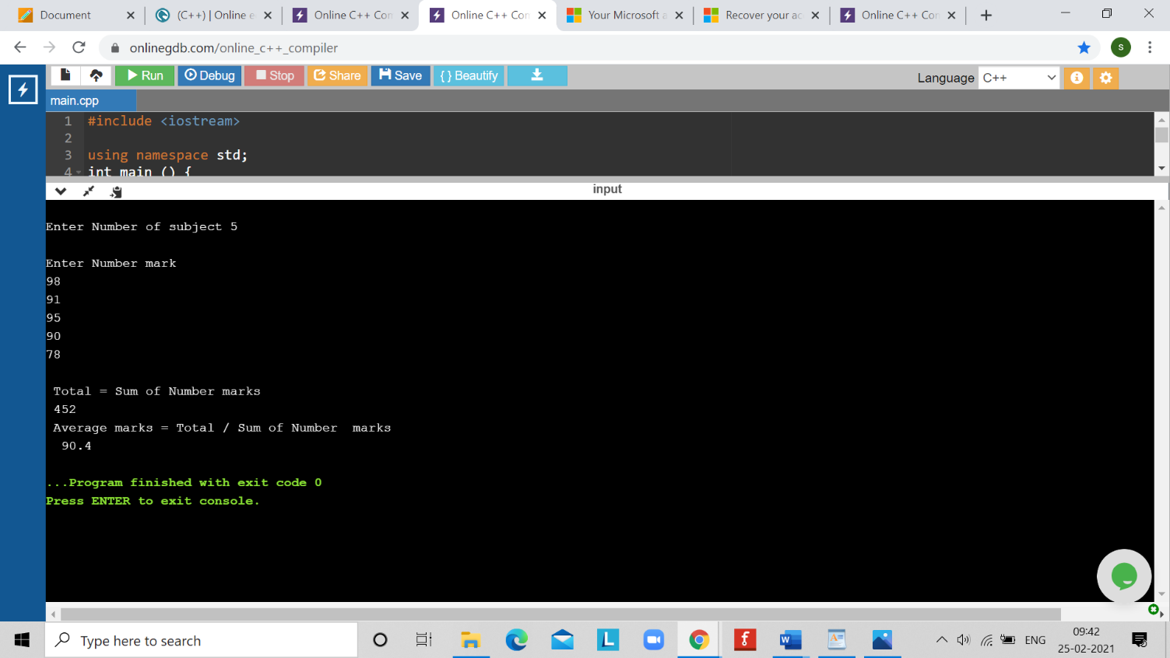

# EXPERIMENT NUMBER –Practical 1.2

STUDENT’S NAME – SHINDE SMITA SHAHAJI

STUDENT’S UID – 20BCS4643

CLASS AND GROUP –CSE-IOT(GROUP B)

SEMESTER – 2ND

# TOPIC OF EXPERIMENT –

# WAP to swap first and last digits of any number.

# AIM OF THE EXPERIMENT-

# Learn the basics of C++ programming.

# FLOWCHART/ ALGORITHM­ –

# START

# Step 1- Declaring the variables in main.

# Step 2→ Taking a number as input from the user.

# Step 3→ Using modulo (%) operator to find the last digit of entered number.

# Step 4→ Now finding first digit by using –> digit =(int)log10(n)

# Step 5→ Swapping the digits by -> last *(pow(10, digits))+(n *10+ first)

# Step 6 → Displaying the output.

# Stop .

# PROGRAM CODE-

# #include <iostream>

# #include <math.h>

# using namespace std;

# int main()

# {

# int n, first, last, sum, digits, nn, a, b;

# cout <<"\n\n Find the number after swapping the first and last digits:\n";

# cout <<"-------------------------------------------------------------\n";

# cout <<" Input any number: ";

# cin >> n;

# digits =(int)log10(n);

# first = n /pow(10, digits);

# last = n %10;

# a = first *(pow(10, digits));

# b = n % a;

# n = b /10;

# nn = last *(pow(10, digits))+(n *10+ first);

# cout <<" The number after swaping the first and last digits are: "<< nn << endl;

# }

ERRORS ENCOUNTERED DURING PROGRAM’S EXECUTION

# (Kindly Note down the compile time errors encountered)

# Semicolons was missing.

# Parenthesis(brackets) was missing.

# Double quotes were missing in string.

# Missing space between “using namespace std”

PROGRAMS’ EXPLANATION (in brief)-

In this program we are swaping the first and last digit of the entered no. by using modulo %operator and dividing by10 for last no. finding first digit by using digit =(int)log10(n).Swaping the digits by last *(pow(10, digits))+(n *10+ first) and Displaying the output

OUTPUT

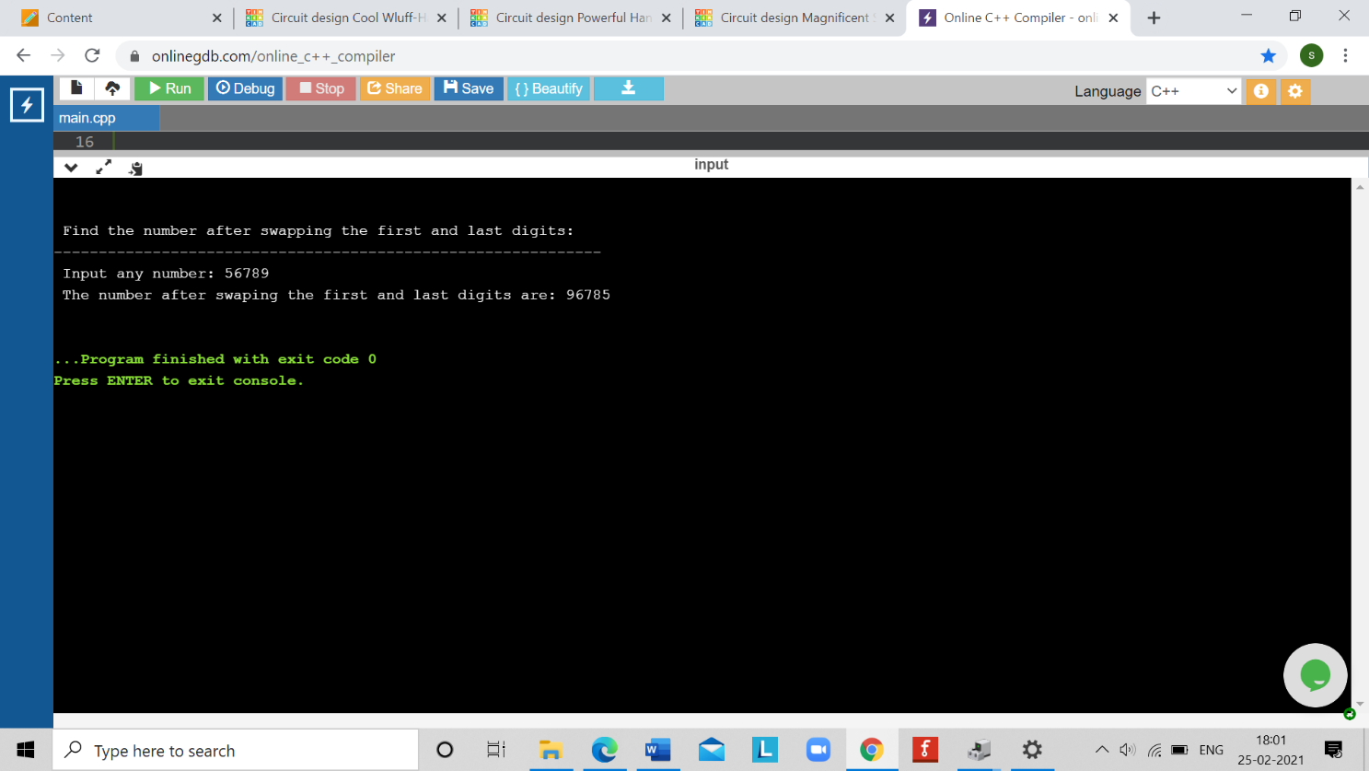

# EXPERIMENT NUMBER –Practical 1.3

STUDENT’S NAME – SHINDE SMITA SHAHAJI

STUDENT’S UID – 20BCS4643

CLASS AND GROUP –CSE-IOT(GROUP B)

SEMESTER – 2ND

# TOPIC OF EXPERIMENT –

# 

# Program to generate the Fibonacci series up to user specified limit and then writing its all the missing terms.

# AIM OF THE EXPRIMENT-

# Learn basic programing in C++

# FLOWCHART/ ALGORITHM-

# START

# Step 1- Declaring the variables in main.

# Step 2 → → Initializing the variables, first=0, second=1, and count =0

# Step 3 → Entering the number of terms of Fibonacci series to be printed.

# Step 4 → Using loop next =first + second; first =second; second =next; Increasing value of i each time by 1.

# Step 5→ now if number is (next-first>1) then printing it as missing terms of the Fibonacci series.

# Step 6→ Displaying the output.

# Stop

PROGRAM CODE

# #include<iostream>

# using namespace std;

# int main()

# {

# int n,c,first=0,second=1,next;

# int a[20],i,j=0,count=0;

# cout<<"Enter how many terms you want in Fibonacci series=";

# cin>>n;

# cout<<"*Terms of Fibonacci series are*"<<endl;

# for(c=0;c<n;c++)

# {

# if(c<=1)

# next=c;

# else

# {

# next=first+second;

# first=second;

# second=next;

# }

# cout<<next<<endl;

# if(next-first>1)

# {

# for(i=first+1; i<next; i++)

# {

# a[j]=i;

# count++;

# j++;

# }

# }

# }

# cout<<"Missing numbers of the Fibonacci series are:"<<endl;

# for(j=0; j<count; j++)

# cout<<a[j]<<endl;

# return 0;

}

ERRORS ENCOUNTERED DURING PROGRAM’S EXECUTION

(Kindly jot down the compile time errors encountered)

# Semicolons was missing.

# Parenthesis(brackets) was missing.

# Double quotes were missing in string.

# Missing space between “using namespace std”

PROGRAMS’ EXPLANATION (in brief) - -

In the given program we are making first Fibonacci series using algo next=first+second;first=second; second=next and then finding the missing terms in the series using algo if(next-first>1) then printing it as missing terms of the Fibonacci series

OUTPUT

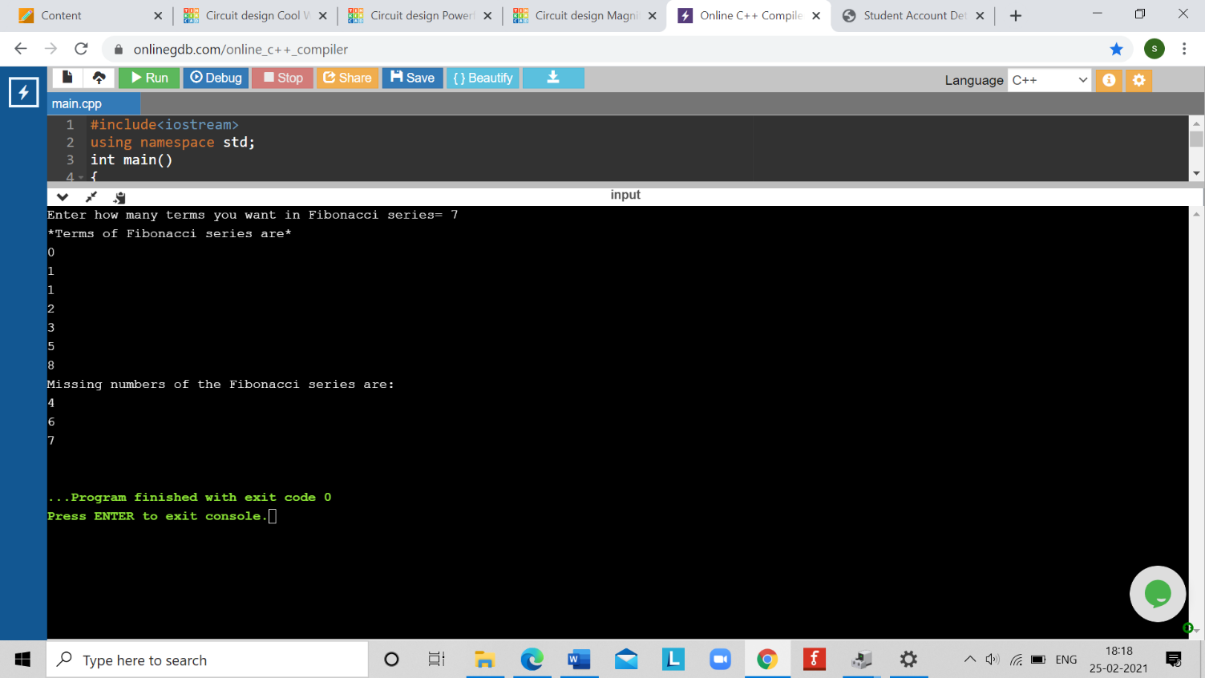

LEARNING OUTCOMES

|  |
| --- |
| * Identify situations where computational methods would be useful. |
| * Approach the programming tasks using techniques learnt and write pseudo-code. |
| * Choose the right data representation formats based on the requirements of the problem. |
| * Use the comparisons and limitations of the various programming constructs and choose the right one for the task. |

EVALUATION COLUMN (To be filled by concerned faculty only)

|  |  |  |  |
| --- | --- | --- | --- |
| **Sr. No.** | **Parameters** | **Maximum**  **Marks** | **Marks**  **Obtained** |
| 1. | Worksheet Completion including writing learning objective/ Outcome | 10 |  |
| 2. | Post Lab Quiz Result | 5 |  |
| 3. | Student engagement in Simulation/ Performance/ Pre Lab Questions | 5 |  |
| 4. | Total Marks | 20 |  |